**Research**

For transmission distances above 600 km, DC transmission is more economical than AC transmission (≥1000 MW). Power transmission of up to 600 - 800 MW over distances of about 300 km has already been achieved with submarine cables. AC cable transmission over more than 80-120 km is technically not feasible due to reactive power limitations.

HVDC applications include cable transmissions, long distance HVDC transmissions with overhead lines and Back to Back (B2B) schemes to interconnect systems operating at different frequencies. HVDC VSC is the preferred technology for interconnecting islanded grids, such as offshore wind farms, to the power system. This technology provides the “Black-Start” feature by means of self-commutated voltage source converters.

HVDC Light

It provides fast AC voltage control and superior voltage stability for Transmission up to 330MW, and for DC voltage in the ± 150kV range. HVDC Light provides independent control of active and reactive power, independent power transfer and power quality control, power reversal, reduced power losses in connected ac systems, increased transfer capacity in the existing system, fast restoration after blackouts, flexibility in design, no relevant magnetic fields, low environmental impact, indoor design and short time schedule. It consists of

Standard Power Transformers are used to regulate AC voltage for the operation of VSC.

AC Filters provide low impedance paths for the harmonics in order to limit them from entering into the connected AC network.

VSCs are made using self-commutated IGBT valve stacks and operate with high frequency Pulse Width Modulation (PWM). They do not have any reactive power demand due to reactive power compensation using STATCOM and fixed filters. HVDC Light VSCs has no minimum short circuit capacity limit due to black-start feature. To switch voltages higher than the rated voltage, several positions are connected in series in each valve. Each IGBT position can be individually regulated in the valve to the correct voltage level. The flexibility of the IGBT makes it possible to block the current immediately if a short circuit is detected.

DC side capacitor provides a low inductance path for the turned off current, serves as an energy store and reduces the harmonic ripple on the direct voltage.

The DC transmission can be achieved using power lines, submarine DC cables or Long Distance Overhead Lines.

Converter Reactors provide low-pass filtering of the Inverter output PWM pattern to give the desired fundamental frequency voltage, provide active and reactive power control and limit the short circuit currents.

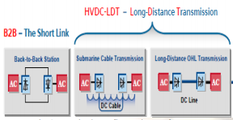 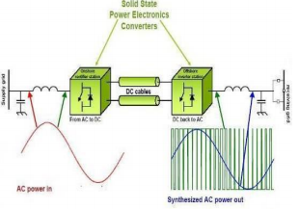

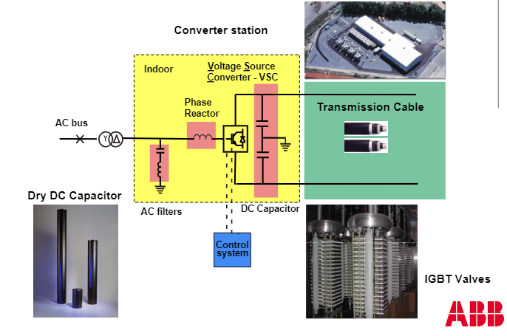 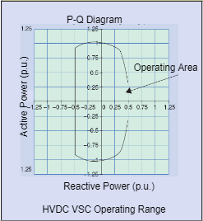

**5 Bus Book Case without HVDC Light**

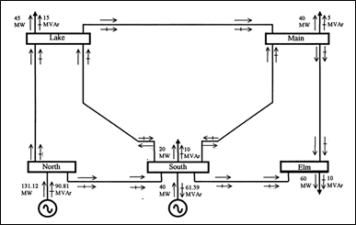

Results

|  |  |  |  |  |  |
| --- | --- | --- | --- | --- | --- |
| Information | North | South | Lake | Main | Elm |
| |V| (p.u.) | 1.06 | 1.00 | 0.987 | 0.984 | 0.972 |
| Θ (degrees) | 0.00 | -2.06 | -4.64 | -4.96 | -5.76 |
| P (p.u.) | 1.311 | 0.200 | -0.450 | -0.400 | -0.600 |
| ΔP (p.u.) |  | -1.64e-13 | -4.51e-14 | -1.88e-14 | 2.63e-14 |
| Q (p.u.) | 0.908 | -0.716 | -0.150 | -0.050 | -0.100 |
| ΔQ (p.u.) |  | 0.616 | -1.613e-13 | -3.393e-14 | 7.780e-14 |



**5 Bus Book Case with HVDC Light**

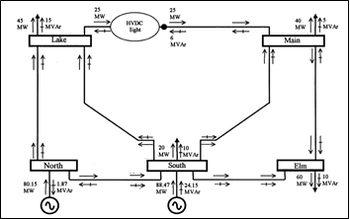

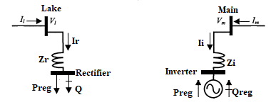

Rectifier is connected to Lake using Zr. Rectifier is modeled as a PQ node to draw desired power Preg=0.25 p.u. from Lake. The voltage of Lake node |Vl| is regulated at 1 p.u.

Inverter is connected to Main using Zi. Inverter is modeled as a PV node to deliver desired active power Preg=0.25 p.u. and absorb desired reactive power Qreg=-0.06 p.u.

The Converters are lossless hence no active power is lost between the Rectifier and Inverter.

The State Variables are the Rectifier phase angle and Inverter Voltage Magnitude. The Rectifier phase angle and Inverter Voltage Magnitude are updated after every iteration:

Results

|  |  |  |  |  |  |  |  |
| --- | --- | --- | --- | --- | --- | --- | --- |
| Information | North | South | Lake | Main | Elm | Rectifier | Inverter |
| |V| (p.u.) | 1.036 | 1.029 | 1.000 | 1.003 | 0.998 | 1.005 | 1.006 |
| Θ (degrees) | 0.00 | -1.41 | -4.64 | -3.55 | -4.72 | 6.20 | -2.50 |
| P (p.u.) | 0.7978 | 0.6789 | -0.4397 | -0.400 | -0.600 | -0.251 | 0.250 |
| ΔP (p.u.) |  | 0.0058 | -0.0103 | -1.44e-15 | -1.22e-15 | 0.00104 | 4.44e-16 |
| Q (p.u.) | -0.029 | 0.1736 | -0.120 | -0.050 | -0.100 | -0.031 | -0.06 |
| ΔQ (p.u.) |  | -0.2736 | -0.0302 | -8.17e-15 | 4.96e-15 | 0.0305 | 2.28e-15 |





**IEEE 14 Bus System without HVDC Light**

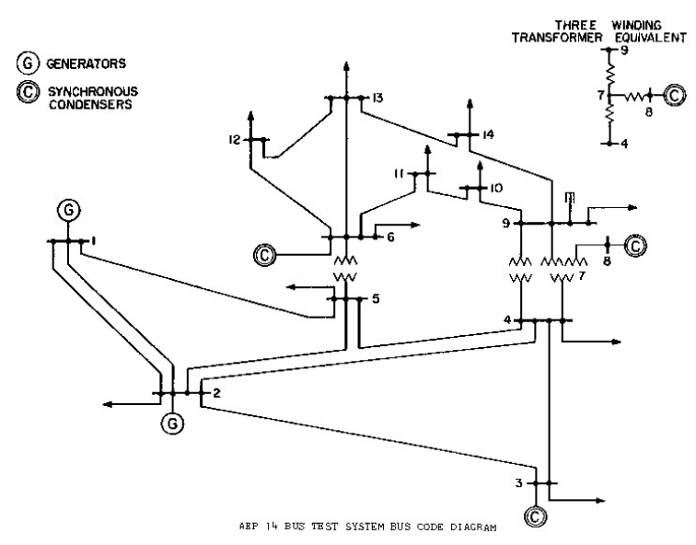

The system consists of 14 buses, 2 generators, 3 synchronous condensers, 11 loads, three transformers and 3 phase shifters. The Generators and Synchronous condensers can deliver active and reactive powers for regulating constant 1.06 p.u. voltage magnitudes at their respective buses.

Results

|  |  |  |  |  |  |  |  |  |  |  |  |  |  |  |
| --- | --- | --- | --- | --- | --- | --- | --- | --- | --- | --- | --- | --- | --- | --- |
| Information | 1 | 2 | 3 | 4 | 5 | 6 | 7 | 8 | 9 | 10 | 11 | 12 | 13 | 14 |
| |V| (p.u.) | 1.060 | 1.060 | 1.060 | 1.048 | 1.048 | 1.060 | 1.040 | 1.060 | 1.024 | 1.024 | 1.039 | 1.049 | 1.043 | 1.021 |
| Θ (degrees) | 0.00 | -6.44 | -15.8 | -13.1 | -11.2 | -17.1 | -16.3 | -16.3 | -18.1 | -18.5 | -18.1 | -18.6 | -18.9 | -20.3 |
| P (p.u.) | 2.44 | 0.183 | -0.942 | -0.478 | -0.076 | -0.112 | 0 | 0 | -0.295 | -0.090 | -0.035 | -0.061 | -0.135 | -0.149 |
| ΔP (p.u.) |  | 6e-16 | -3e-15 | -4e-15 | 5e-16 | 2e-15 | -8e-16 | 1e-16 | -6e-15 | 1e-15 | -5e-16 | -6e-16 | -3e-16 | 4e-16 |
| Q (p.u.) | 0.213 | 0.309 | 0.119 | 0.039 | -0.016 | 0.274 | 0 | 0.123 | -0.166 | -0.058 | -0.018 | -0.016 | -0.058 | -0.050 |
| ΔQ (p.u.) |  | -0.01 | -0.075 | 4e-15 | -6e-15 | -0.227 | 0 | 0.050 | 3e-15 | -1e-15 | 6e-16 | 9e-16 | -1e-15 | -2e-15 |



**IEEE 14 Bus System with HVDC Light**

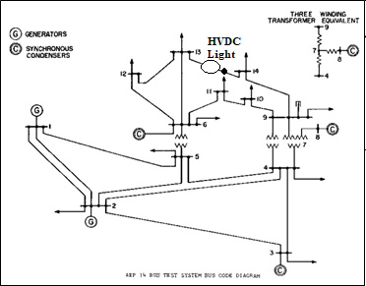

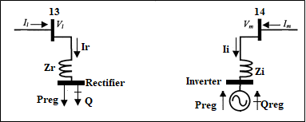

Rectifier is connected to bus 13 using Zr. Rectifier is modeled as a PQ node to draw desired power Preg=0.25 p.u. from Lake. The voltage of bus 13 is regulated at 1.06 p.u.

Inverter is connected to bus 14 using Zi. Inverter is modeled as a PV node to deliver desired active power Preg=0.25 p.u. and absorb desired reactive power Qreg=-0.06 p.u.

The Converters are lossless hence no active power is lost between the Rectifier and Inverter.

The State Variables are the Rectifier phase angle and Inverter Voltage Magnitude. The Rectifier phase angle and Inverter Voltage Magnitude are updated after every iteration:

Results

|  |  |  |  |  |  |  |  |  |  |  |  |  |  |  |  |  |
| --- | --- | --- | --- | --- | --- | --- | --- | --- | --- | --- | --- | --- | --- | --- | --- | --- |
| Information | 1 | 2 | 3 | 4 | 5 | 6 | 7 | 8 | 9 | 10 | 11 | 12 | 13 | 14 | Rectifier | Inverter |
| |V| (p.u.) | 1.060 | 1.060 | 1.060 | 1.048 | 1.048 | 1.060 | 1.034 | 1.060 | 1.011 | 1.013 | 1.033 | 1.056 | 1.060 | 0.965 | 1.060 | 1.007 |
| Θ (degrees) | 0.00 | -5.85 | -14.8 | -12.1 | -10.6 | -18.1 | -14.7 | -14.7 | -16.1 | -17.0 | -17.8 | -20.3 | -21.5 | -13.9 | -21.6 | -13.2 |
| P (p.u.) | 2.20 | 0.183 | -0.942 | -0.478 | -0.076 | -0.112 | 0 | 0 | -0.295 | -0.090 | -0.035 | -0.061 | -0.135 | -0.149 | -0.250 | 0.250 |
| ΔP (p.u.) |  | -8e-10 | -1e-9 | 1e-9 | -6e-10 | -2e-5 | -6e-9 | -1e-9 | 2e-9 | 5e-10 | 6e-10 | -4e-6 | 1e-5 | -3e-7 | 2e-5 | 1e-7 |
| Q (p.u.) | 0.126 | 0.182 | 0.080 | 0.039 | -0.016 | 0.195 | 0 | 0.157 | -0.166 | -0.058 | -0.018 | -0.018 | 0.020 | -0.050 | 0.0003 | -0.060 |
| ΔQ (p.u.) |  | 0.211 | 0.270 | 1e-9 | 1e-8 | -0.291 | 1.5e-7 | -0.116 | -2e-8 | -9e-9 | 4e-8 | 2e-4 | -0.01 | -8e-8 | -2e-4 | -1e-8 |





**IEEE 14 Bus System with New HVDC Light Model**

The New HVDC Light Model is different from the Book HVDC Light Model in that the Converters are connected using DC cables which contribute to active power loss. The loss is dependent on the constant DC voltage level and DC cable resistance.



Furthermore, the VSCs have a well-defined P-Q Diagram like the Generators and Synchronous Condensers. These graphs limit their operation and ability to regulate active and reactive power.

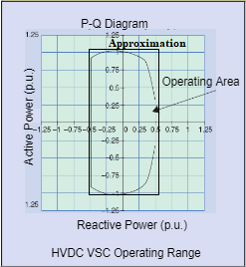

The New HVDC Model is shown below.

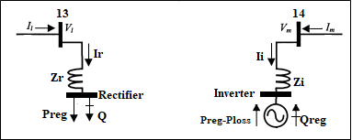

Rectifier is connected to bus 13 using Zr. Rectifier is modeled as a PQ node to draw desired power Preg=0.25 p.u. from Lake. The voltage of bus 13 is regulated at 1.06 p.u.

Inverter is connected to bus 14 using Zi. Inverter is modeled as a PV node to absorb desired reactive power Qreg=-0.06 p.u.

Power Ploss is lost between Rectifier and Inverter due to the DC cable.

The State Variables are the Rectifier phase angle and Inverter Voltage Magnitude. The Rectifier phase angle and Inverter Voltage Magnitude are updated after every iteration:

Results

|  |  |  |  |  |  |  |  |  |  |  |  |  |  |  |  |  |
| --- | --- | --- | --- | --- | --- | --- | --- | --- | --- | --- | --- | --- | --- | --- | --- | --- |
| Information | 1 | 2 | 3 | 4 | 5 | 6 | 7 | 8 | 9 | 10 | 11 | 12 | 13 | 14 | Rectifier | Inverter |
| |V| (p.u.) | 1.060 | 1.060 | 1.060 | 1.048 | 1.049 | 1.060 | 1.034 | 1.060 | 1.011 | 1.013 | 1.033 | 1.056 | 1.060 | 0.965 | 1.060 | 0.999 |
| Θ (degrees) | 0.00 | -5.97 | -15.1 | -12.5 | -10.9 | -18.5 | -15.3 | -15.2 | -16.8 | -17.7 | -18.3 | -20.7 | -21.9 | -15.8 | -21.9 | -15.0 |
| P (p.u.) | 2.25 | 0.183 | -0.942 | -0.478 | -0.076 | -0.112 | 0 | 0 | -0.295 | -0.090 | -0.035 | -0.061 | -0.135 | -0.149 | -0.250 | 0.200 |
| ΔP (p.u.) |  | -1e-9 | 3e-10 | 4e-9 | -1e-10 | -2e-4 | -5e-9 | -9e-10 | -9e-11 | 3e-10 | 4e-10 | -3e-5 | 8e-5 | -2e-7 | 1e-4 | 1e-7 |
| Q (p.u.) | 0.133 | 0.192 | 0.083 | 0.039 | -0.016 | 0.198 | 0 | 0.158 | -0.166 | -0.058 | -0.018 | -0.018 | 0.020 | -0.050 | 0.0003 | -0.060 |
| ΔQ (p.u.) |  | 0.105 | 0.039 | 5e-8 | 2e-9 | -0.151 | 1e-7 | 0.016 | -2e-8 | -1e-8 | 3e-8 | 0.002 | -0.078 | -7e-8 | -2e-4 | 7e-9 |





REFERENCES

A. K. Mohanty and A. K. Barik, “Hvdc light and facts technology: A modern approach to power system interconnections,” International Journal of Engineering Research and Applications (IJERA) Vol, vol. 2, pp. 1331–1336b.

M. Barnes and A. Beddard, “Voltage Source Converter HVDC Links – The state of the Art and Issues Going Forward”, Energy Procedia, vol. 24, 2012, pp. 108–122.

R. Sellick and M. Akerberg, “Comparison of HVDC Light (VSC) and HVDC Classic (LCC) Site Aspects, for a 500MW 400kV HVDC Transmission Scheme”, 10th IET International Conference on AC and DC Power Transmission (ACDC 2012), pp. 1-7.

M.Callavik et al., “ENERGY TRANSITION Evolution of HVDC Light”, ABB Review 2018, pp. 1-8.

S. Mukherjee at al., “Cable Overvoltage for MMC based VSC HVDC System: Interaction with Converters”, CIGRE Study Committee B1 Meeting and International Colloquium, New Delhi, India, 2017, pp. 1-9.

A. Hassanpoor et al., “Cost-Effective Solutions for Handling Dc Faults in VSC HVDC Transmission”, EPE2016, Karlsruhe, Germany, 2016, pp. 1-7.

V. Donde et al., “Distributed State Estimation of Hybrid AC/HVDC Grids by Network Decomposition”, IEEE Transactions on SMART Grid, March 2016, Vol. 7, pp. 1-9.

P. Lundberg et al., “VSC HVDC Transmission Supporting Variable Electricity Generation”, The International Council on Large Electric Systems, 2016, pp. 1-9.